## Task 01: Export Geo Location Reference

|  |
| --- |
| CREATE TABLE exp_country AS  SELECT lcc.geo_id AS country_geo_id  , lcc.country_id  , lcc.country_code_a3  , lcc.country_desc AS country_desc  , NVL ( lcr.geo_id, -99 ) AS region_geo_id  , NVL ( lcr.region_id, -99 ) AS region_id  , NVL ( lcr.region_code, 'n.d.' ) AS region_code  , NVL ( lcr.region_desc, 'n.d.' ) AS region_desc  , NVL ( lcp.geo_id, -99 ) AS part_geo_id  , NVL ( lcp.part_id, -99 ) AS part_id  , NVL ( lcp.part_code, 'n.d.' ) AS part_code  , NVL ( lcp.part_desc, 'n.d.' ) AS part_desc  , NVL ( lcs.geo_id, -99 ) AS geo_system_geo_id  , NVL ( lcs.geo_id, -99 ) AS geo_system_id  , NVL ( lcs.geo_system_code, 'n.d.' ) AS geo_system_code  , NVL ( lcs.geo_system_desc, 'n.d.' ) AS geo_system_desc  , NVL ( lcsg.geo_id, -99 ) AS sub_group_geo_id  , NVL ( lcsg.sub_group_id, -99 ) AS sub_group_id  , NVL ( lcsg.sub_group_code, 'n.d.' ) AS sub_group_code  , NVL ( lcsg.sub_group_desc, 'n.d.' ) AS sub_group_desc  , NVL ( lcg.geo_id, -99 ) AS group_geo_id  , NVL ( lcg.GROUP_ID, -99 ) AS GROUP_ID  , NVL ( lcg.group_code, 'n.d.' ) AS group_code  , NVL ( lcg.group_desc, 'n.d.' ) AS group_desc  , NVL ( lcgs.geo_id, -99 ) AS grp_system_geo_id  , NVL ( lcgs.grp_system_id, -99 ) AS grp_system_id  , NVL ( lcgs.grp_system_code, 'n.d.' ) AS grp_system_code  , NVL ( lcgs.grp_system_desc, 'n.d.' ) AS grp_system_desc  FROM (SELECT *  FROM ( SELECT parent_geo_id AS geo_id  , CONNECT_BY_ROOT child_geo_id AS roo  , link_type_id  FROM t_geo_object_links gol  START WITH child_geo_id IN (SELECT geo_id  FROM lc_countries)  CONNECT BY PRIOR parent_geo_id = child_geo_id) PIVOT (SUM ( geo_id )  FOR link_type_id  IN (1 AS l_1  , 2 AS l_2  , 3 AS l_3  , 4 AS l_4  , 5 AS l_5  , 6 AS l_6))) piv  LEFT JOIN lc_countries lcc  ON piv.roo = lcc.geo_id  LEFT JOIN lc_geo_regions lcr  ON lcr.geo_id = piv.l_3  LEFT JOIN lc_geo_parts lcp  ON lcp.geo_id = piv.l_2  LEFT JOIN lc_geo_systems lcs  ON piv.l_1 = lcs.geo_id  LEFT JOIN lc_cntr_sub_groups lcsg  ON piv.l_4 = lcsg.geo_id  LEFT JOIN lc_cntr_groups lcg  ON piv.l_5 = lcg.geo_id  LEFT JOIN lc_cntr_group_systems lcgs  ON piv.l_6 = lcgs.geo_id  ORDER BY roo; |

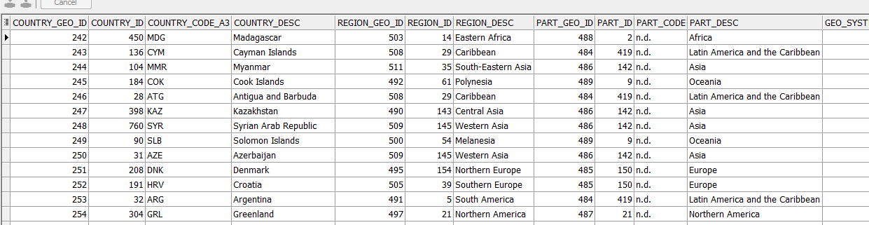

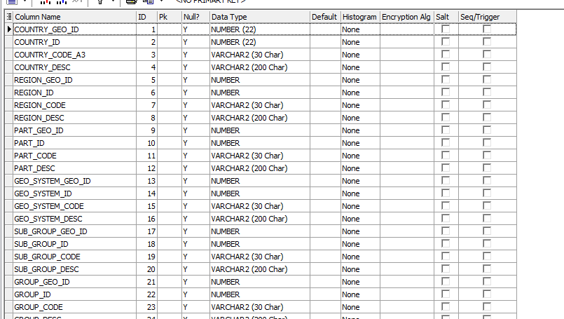

CONNECT BY AND ADDITIONAL COLOUMNS

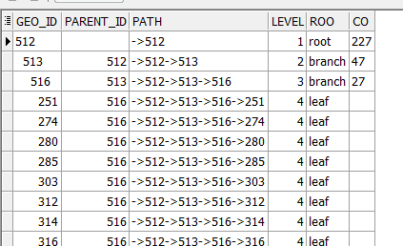

|  |
| --- |
| SELECT LPAD ( ' '  , 2 * ( LEVEL - 1 ) )  || child_geo_id  AS geo_id  , parent_geo_id AS parent_id  , SYS_CONNECT_BY_PATH ( child_geo_id  , '->' )  AS PATH  , LEVEL  , CASE  WHEN CONNECT_BY_ROOT child_geo_id = child_geo_id THEN 'root'  WHEN CONNECT_BY_ISLEAF = 1 THEN 'leaf'  ELSE 'branch'  END  AS roo  , DECODE ( CONNECT_BY_ISLEAF  , 1, NULL  , ( SELECT COUNT ( child_geo_id )  FROM t_geo_object_links  START WITH parent_geo_id = gol.child_geo_id  CONNECT BY PRIOR child_geo_id = parent_geo_id ) )  AS co  FROM (SELECT *  FROM t_geo_object_links  UNION ALL  SELECT NULL  , geo_id  , NULL  FROM lc_cntr_group_systems) gol  START WITH parent_geo_id IS NULL  CONNECT BY PRIOR child_geo_id = parent_geo_id  ORDER SIBLINGS BY child_geo_id; |

## Task 02: Analyse Business hierarch Reference Analyses

**The Main Task** is to create hierarch analyses of any Dimension, according yours Solution Proposal and DWH Solution Concept from Module 6. Introduction to DWH

|  |
| --- |
| SELECT lcc.geo_id AS country_geo_id  , lcc.country_id  , lcc.country_code_a3  , lcc.country_desc AS country_desc  , NVL ( lcr.geo_id, -99 ) AS region_geo_id  , NVL ( lcr.region_id, -99 ) AS region_id  , NVL ( lcr.region_desc, 'n.d.' ) AS region_desc  , NVL ( lcp.geo_id, -99 ) AS part_geo_id  , NVL ( lcp.part_id, -99 ) AS part_id  , NVL ( lcp.part_desc, 'n.d.' ) AS part_desc  FROM (SELECT *  FROM ( SELECT parent_geo_id AS geo_id  , CONNECT_BY_ROOT child_geo_id AS roo  , link_type_id  FROM t_geo_object_links gol  START WITH child_geo_id IN (SELECT geo_id  FROM lc_countries)  CONNECT BY PRIOR parent_geo_id = child_geo_id) PIVOT (SUM ( geo_id )  FOR link_type_id  IN (2 AS l_2  , 3 AS l_3  ))) piv  LEFT JOIN lc_countries lcc  ON piv.roo = lcc.geo_id AND lcc.localization_id = (:loc_param)  LEFT JOIN lc_geo_regions lcr  ON lcr.geo_id = piv.l_3 AND lcr.localization_id = (:loc_param)  LEFT JOIN lc_geo_parts lcp  ON lcp.geo_id = piv.l_2 AND lcp.localization_id = (:loc_param)  ORDER BY roo; |

**Required points:**

* Create Denormalized table data using CONNENT_BY
* Use START WITH Clause
* Use CONNECT_BY_ROOT to analyses any Branch levels
* Analyze Main Root Branch, and 2 Sub Branches

**Task Results:**

Create required objects:

* + Prepare Document with Screenshot of analyses Data result
  + Prepare script and put it to GIT